|  |  |
| --- | --- |
| NAME | Muhammad Arslan Raza |
| ROLL# | 2020-EE-403 |

**Lab 8: Problem Set 3**

**Objective:** The objective of this problem set is how to write different programs on compiler

**Task 1:**

Implement the following function:  
a) *factorial (n)*--- which takes a number as parameter and return its factorial.  
Call the above function. Initialize an integer variable from the user and pass it as  
parameter to the above function. Then display the factorial

**Code:**

def factorial(n):

factorial=1

for i in range(1,x+1):

factorial=factorial*i

return(factorial)

x=int(input("Enter The Number=",))

print(factorial(x))

**Output:**

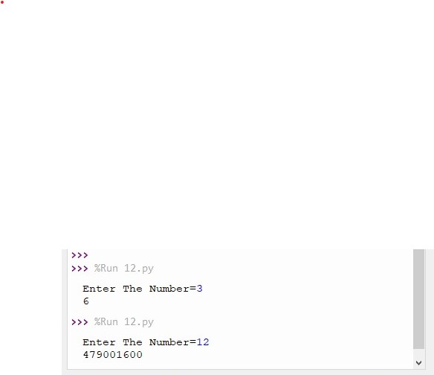

**Task 2:**

Modify the factorial program to call the factorial function 10 times while passing a user  
defined integer each time and displaying the corresponding factorial.

**Code:**

def factorial(n):

factorial=1

for i in range(1,x+1):

factorial=factorial*i

return(factorial)

for i in range(10):

x=int(input("Enter The Number=",))

print(factorial(x))

**Output:**

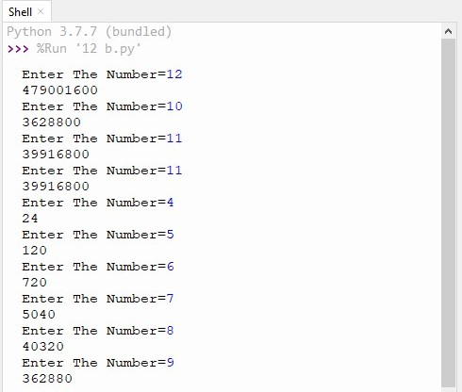

**Task 3:**

An integer number is said to be a perfect number if the sum of its factors, including 1 (but not the number itself), is equal to the number. For example, 6 is a perfect number,  
because 6 = 1 + 2 + 3. Write a function *perfect* that determines whether parameter  
*number* is a perfect number. Use this function in a program that determines and prints all  
the perfect numbers between 1 and 1000. Print the factors of each perfect number to  
confirm that the number is indeed perfect.

**Code:**

def is_perfect(x):

sum = 0

for n in range (1,x):

if x % n == 0:

sum =sum+n

if sum == x:

return True

else:

return False

def factors(x):

factors = []

for n in range (1,x):

if x % n == 0:

factors.append(n)

return factors

for num in range(1,1000):

if is_perfect(num) == True:

print(num,'is perfect.',end = ' ')

print ('Factors are:',end = ' ')

for x in factors(num):

print(x,end=' ')

print()

**Output:**

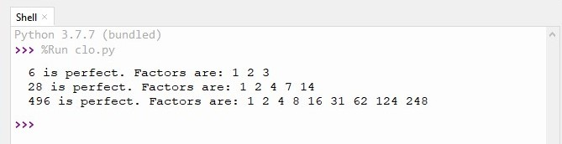

**Conclusion:**

Today I learn how to write a program which takes a number as parameter and return its factorial.  
Call the above function. Initialize an integer variable from the user and pass it as  
parameter to the above function. Then display the factorial, Modify the factorial program to call the factorial function 10 times while passing a user defined integer each time and displaying the corresponding factorial. And An integer number is said to be a perfect number if the sum of its factors, including 1 (but not the number itself), is equal to the number. For example, 6 is a perfect number, because 6 = 1 + 2 + 3. Write a function *perfect* that determines whether parameter  
*number* is a perfect number. Use this function in a program that determines and prints all  
the perfect numbers between 1 and 1000. Print the factors of each perfect number to  
confirm that the number is indeed perfect.